Concept Based Querying of Documents Using Hypernym Generalisation and Latent Semantic Indexing



Thesis submitted to
Visvesvaraya National Institute of Technology, Nagpur
In fulfillment of requirement for the degree of
Bachelor of Technology in Computer Science Engineering
by

Aditya Tayade Ankit Tare
Ankit Ramteke Divyanshu Kumar Singh
Jyotesh Choudhari Rahul Sharnagat

Under the Supervision of
Dr. U.A. Deshpande

Department of Computer Science Engineering,
Visvesvaraya National Institute of Technology, Nagpur-440010
2010-2011
Certificate

This is to certify that the project titled “Concept Based Querying of Documents using Hypernym Generalisation and Latent Semantic Indexing ”, being submitted by my students – Mr. Aditya Tayade, Mr. Ankit Tare, Mr. Ankit Ramteke, Mr. Divyanshu Kumar Singh ,Mr.Jyotesh Choudhari,Mr. Rahul Sharnagat– in partial fulfillment of the requirement for the completion of the course for the degree of Bachelor of Technology in Computer Science Engineering, is a record of the students’ own work carried out by them under my supervision and guidance.

Date: (Dr. U. A. Deshpande)

Countersigned by

(Dr. K.D.Kulat)

Professor and Head of Department,
Computer Science Engineering,
Visvesvaraya National Institute of Technology, Nagpur

Declaration

This project, titled “Concept Based Querying of documents using Hypernym Generalization and Latent Semantic Indexing” is work carried out by us under the guidance of Dr. U. A. Deshpande, Department of Computer Science Engineering, Visvesvaraya National Institute of Technology, Nagpur; this project has not been submitted to any other Institute or University for any degree or diploma.

Date:

-Aditya Tayade
-Ankit Tare
-Ankit Ramteke
-Divyanshu Kumar Singh
-Jyotesh Choudhari
-Rahul Sharnagat

Acknowledgement

We will like to express our gratitude to every member of the project who have contributed directly or indirectly in the completion of this project. We will like to acknowledge and appreciate the efforts, valuable help, guidance and criticism that led our project towards success.
We take up this precious opportunity to express our gratitude towards our guide Dr. U. A. Deshpande for his guidance and providing helping hands throughout the project.
We would like to express our sincere thanks to Dr. K. D. Kulat, without whom this project would not have completed.
We are grateful to all the faculty members, department authorities, and our friends who have helped us directly or indirectly to make this project a success.

Abstract

With the explosion of the amount of information on the web there is a growing need for search mechanisms which can deliver results taking the semantic contexts of the web pages & the query into consideration. Here we propose a document retrieval method which takes the semantics of the query and then returns the documents which are “similar” in meaning to that of the query.

Natural language queries, although following certain grammatical structures, are quite ambiguous. It is almost impossible to make a perfect analytical grammar that will generate the whole English language. All we can do is guess with a certain probability the part of speech to which the word belongs & then use the meaning and the context to of the words to find the meaning of the sentence. Thus, the classical programming language concepts cannot be applied to natural languages. The crux of any semantic search mechanism is the way in which the query & the documents are processed by the search engine.

In the search technique proposed here, the query is tagged to understand the grammatical structure of the sentence. This structure, along with the generic meaning of the words appearing in the query is to find central concept spaces to which the query belongs to. This is done using hypernym* generalization & Latent Semantic Indexing** (LSI). Noise reduction in the query set is carried out. This gives us a set of relevant documents. Generally these sets are huge and are not of any practical significance to the user. Hence, we apply a ranking mechanism to render only the most relevant documents as the result.

* A word or a phrase that encompasses the semantic field of any other word.
** Also called Latent Semantic Analysis (LSA) (US Patent 4,839,853)
The implementation was carried out completely using the Python programming environment and the python Natural Language Processing Toolkit(NLTK).

We have done extensive experimentation and saw the performance metrics like concept map, singular valued decomposition matrices, ranking parameters against variety of queries based on different topics. We have also compared the results of the queries with the Google results. A comparative study about the efficacy of the technique, the advantages and the shortcomings has also been carried out.

Table of Contents

1 Introduction
2 Topics Related To Retrieval
2.1 Natural Language Processing Resources.
2.1.1 Part of Speech Tagging(POS).
2.1.2 Hypernym Generalization.
2.1.3 NLTK usage in Document Retrieval.
2.2 Latent Semantic Indexing(LSI).
2.3 Singular value Decomposition (SVD).
2.4 Ranking
2.4.1 kD-Tree Implementation.
2.4.2 Nearest Neighbor Search

3 Concept Based Retrieval Implementation
3.1 Part of Speech (POS) and Generalization Implementation
3.2 LSI Implementation
3.3 SVD Matrix Simulation
3.4 Nearest Neighbour Search Implementation.
. 3.5 Results

4 Experimental Set up.

5 Conclusions and Future Scope.

6 References.

CHAPTER 1

INTRODUCTION

Document retrieval[1] is a technique in which some user stated query is matched against documents available in database and then retrieving the documents that are closely related to user query. These predefined documents could be of any type mainly, unstructured text files, such as sports related articles, politics related articles, banking records or paragraphs of journalism. User queries can range from multi-sentence descriptions to few words.
Document retrieval is sometimes referred to as, or as a branch of, Text Retrieval. Text retrieval techniques makes use of proper search algorithm to retrieve documents or records which are conceptually equivalent to the query fired.
A document retrieval system consists of a database of documents, a classification algorithm to build a full text index, and a user interface to access the database.
A document retrieval system has two main tasks:
- Find relevant documents to user queries.
- Evaluate the matching results and sort them according to relevance, using algorithms related to information retrieval such as Nearest Neighbor Search algorithm.
Proposed, here forth, are the two search techniques which are widely used in retrieving documents or text from a database
Information Retrieval

The retrieval technique[1] treats each query as formal representation of words such as string representation of words. It tries to identify each word in a document and store each word in its database. Information collected on this basis are then processed to match the underlying theme of the query fired. It takes care of several words which may point to the same theme of the query but with different degree of relevancy. Often the documents themselves are not kept or stored directly in the IR system, but are instead represented in the system by metadata.

Many different measures for evaluating the performance of information retrieval systems have been proposed. These measures require a huge collection of documents and a query. IR techniques also take care of issues related to polysemy in which same word have several meaning.

Web Based Search
In web based search[1] technique, the search engine stores every word in its database and examines every word closely in its stored database so as to match every word of the query with the predefined set of words. Web based technique divides its searching process in two stage. In the first stage, Web Based search scans all the documents in the database and breaks them into set of words and maintains an array for storing these words. This splitting of words and maintaining a list of words is known as Indexing. The indexing process is carried out by Web Based search to deal with potentially huge set of words. In second stage, search is performed on the query by referencing only the index maintained by the words rather than referencing the whole query. Web search Techniques are basically used in regular expression matching, text processing, phrase search, fuzzy search and image vision methodology.

Our experimentation is carried out on several examples, related to various topics, to generate or retrieve useful set of texts or documents. We used various techniques like POS tagging, Hypernym Generalisation, Latent Semantic Indexing, KD-tree implementation to retrieve relevant piece of information from the database maintained in the Python environment. Our experiments and work mainly deals with more specific search and retrieval of documents. The work carried out also eliminates redundancies in the search technique. We have extensively used Python interface and NLTK (Natural Language Processing Toolkit) in implementing above mentioned procedures.

“U.S. intelligence cannot say conclusively that Saddam Hussein has weapons of mass destruction, an information gap that is complicating White House efforts to build support for an attack on Saddam’s Iraqi regime. The CIA has advised top administration officials to assume that Iraq has some weapons of mass destruction. But the agency has not given President Bush a “smoking gun,” according to U.S. intelligence and administration officials.”

This example talks about the attack of US intelligence army on the Iraqi regime governed by Saddam Hussein. The central theme lies whether there should be an attack made by US intelligence on regime on account of missing evidences. Informational Retrieval technique helps in dealing with such documents to collect useful set of words.
The search procedure goes as follows:
Given query is broken into words and each word are then indexed into an array. Array maintains only useful set of words and eliminates various redundant parts of speeches by POS tagging which we will explain in the coming chapter. Then the generalisation procedure is implemented on the given array of words to generate words which are more generic. From this generalised set, we try to establish relationship between the words and terms contained in the original query. This helps in generating texts or documents which are more conceptually and closely related to given query. After all the documents are generated through informational retrieval techniques, ranking of the documents is required to be done. Indexing of the words, collecting useful set of words, generalisation is done via IR techniques which will be explained in details in the coming chapters.
The following chapters will explain in details the techniques used for conceptual retrieval of documents such as POS Tagging, Hypernym Generalisation, Latent Semantic Indexing, Singular Value Decomposition (SVD) and Ranking Mechanisms. The experiment chapter will explain successful evaluation of query using all the techniques required for query processing. Finally, results and distinguishing features of this project are presented at the end.

CHAPTER 2
Topics Related to Retrieval

Retrieval technique incorporates various parameters and mechanism for processing the text. In this section we will explain the resources used in conceptual retrieval of documents. Each concept used in the project are discussed below.

  - Natural Language Processing Resources
Document retrieval effectiveness [4] is easier to improve by NLP-based approaches and resources used by it. NLP is extensively used in processing raw text to generate useful piece of information. Natural Language Processing toolkit (NLTK) makes use of various NLP algorithms to process raw text. NLP techniques helps in converting chunks of texts into more useful text representations and is extensively used in POS tagging where each word is tagged correspondingly to their “part of speech” tag. PoS tagging helps in dealing with polysemy and sentence breaking. It also eliminates stop words such as punctuation marks and other abbreviated symbols from the raw text. In IR technique of documents retrieval, PoS tagging is found to be extremely useful in stemming, categorizing and tokenization of the text. NLP [4][5] resources are used in extracting information from text resources like thesauri, lexicons, dictionaries, proper name databases, are used regularly in information retrieval research. It seems therefore that NLP resources rather than NLP techniques are having more of an impact on document retrieval effectiveness at present. Part of the reason for this is that natural language processing techniques are generally not designed to handle large amounts of text from many different domains. What is needed is the development of NLP resources specifically for document retrieval and vice versa the development of document retrieval techniques specifically for taking advantage of NLP techniques and its resources. Few NLP resources required for processing of the text in our project are
Discussed below :

2.1.1. Part-of-Speech (POS) Tagging

Part of Speech tagging[2][6] forms an indispensible part of query processing where a query is broken into words or objects and then each word is uniquely given a tag and words are tagged as nouns, pronouns, verbs etc. The basic idea behind POS tagging is to tag each word with its respective part of speech. When query is broken down into words, each word is given unique id to make distinction from other words. This process is called “tokenization” of words. A placeholder is maintained for storing all these set of words along with their unique tokens. These tokens are stored as “identifiers” in python libraries. Then the query is sliced so that only useful set of words are extracted from the tokenized ones. This process is called as “slicing the text”. The “sliced” set of words so obtained are then provided with tags of their respective part of speeches as nouns, pronouns etc. Part of speech tagger in NLTK uses various corpora to distinguish words as nouns, pronouns, verbs, adverbs etc. In our previous shown example, if we apply POS tagging we get the following set of words after removing all the stop words, punctuation marks etc.

Results After POS tagging:

  - [U.s. intelligence ,saddam Hussein ,weapons of mass destructions , information gap ,complicating , White House, attack, saddam’s Iraqi regime ,CIA, advised , administration officials , Iraq ,weapons of mass destruction , agency, president bush, U.S. Intelligence, administration officials]

After applying POS tagging on set of words of a query, we apply hypernym generalization to get more generalized set of words from the given piece of data. Word Net hypernyms are used in generalizing PoS tags to a wider concept space.

2.1.2 Hypernym Generalisation.
Hypernym Generalization[6] is a technique which provides us with words that cover much broader concept space of the document under consideration rather than directly searching for keywords of that document . Many a times , it so happens that if we apply direct search on query, the results get skewed towards the documents containing the query words. Documents in which the relevant data is present but not the exact query words are left out from the search. This is what we are trying to overcome with hypernym generalization algorithm. The results after hypernym generalisation on the above described query will be:
Results :
  - weapons of mass destructions ,attack generalises to weapons
  - U.s. intelligence ,CIA generalizes to intelligence services
  - White house, administration gives governance
List = [weapons, intelligence service, governance, evidence]
But the results obtained after actually applying the algorithm had some noise created by WordNet Database .
When a query related to the windows operating system was given to the system we obtained results which contained words like operating system ,computer_code, software . These are the general terms for words in query like Windows and MSDOS which was solely based on windows operating system. Now search could expand, out of the bounds of words from actual query and derive results from more related concepts. As we have combined these generalized words with actual words, our concept space has expanded from a mere circle surrounding windows operating system to more general ideas of windows ,software and computer programme .
This algorithm required certain modifications, as we observed that there are lot of words which aren't particularly relevant to search. Certain limitation to refine the result come from underlying WordNet database. Also generalization of adverbs and adjectives doesn't provide any significant results but adds noise to the search .Hence in the actual implementation, we have considered only the generalization of nouns and verbs from the query. This algorithm tries to combine the words that are closely related and adds a more general word against those words. If a word is unique in concept then it is not generalized.
As far the actual implementation results are concerned, after taking above corrective steps, results are far better as compared to the application of LSI alone on a query.

2.1.3 NLTK Usage in Document Retrieval.
Penn Tree Bank[3] of NLTK interface is used in dealing with words generated after POS tagging and Hypernym Generalisation. Penn Tree Bank is specifically used in the field of computing linguistics. It contains set of words, also known as linguistic dictionary, in its library.
Penn Tree Bank has skeletal parses showing rough syntactic and semantic information -- a bank of linguistic trees. It also has text annotated with part-of-speech tags, and for the Switchboard corpus of telephone conversations, dysfluency annotation

2.2. Latent Semantic Indexing (LSI).
LSI[7] is indexing and retrieval method that identifies pattern in the relationship between terms and concepts that occur in an unstructured collection of text. It uncovers the underlying semantic structure in the usage of words in the body text and how it can be used to extract meaning of the text in response to user query. LSI uses linear algebraic technique to learn the conceptual co-relations in a collection of text, that is, LSI considers documents that have many words in common to be semantically close and docs with few words common to be semantically distant[7]. Google has long been using Latent Semantic Indexing for adsense to display relevant advertisement on adsense publisher s websites. Undeniable evidence suggests that Google is also giving LSI more emphasis in its search algorithm to provide its visitors with relevant information.
Final Set of words on which LSI would work:
Words=[U.s. intelligence ,saddam Hussein ,weapons of mass destructions , information gap ,complicating , White House, attack, saddam’s Iraqi regime ,CIA, advised , administration officials , Iraq ,agency, president bush, administration officials, weapons,intelligence service,governance,evidence]
LSI will prepare a word-document matrix in which columns represent frequency of words occurring in a document and row represent words.
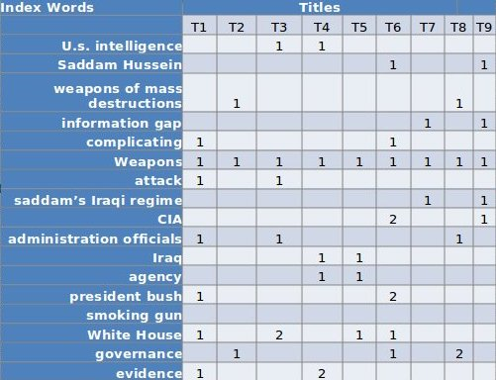

Uses of LSI
LSI is generally acknowledged that the ability to work with text on a semantic basis is essential to modern information retrieval systems. As a result, the use of LSI has significantly expanded in recent years as earlier challenges in scalability and performance have been overcome[8][9].
LSI is being used in a variety of information retrieval and text processing applications, although its primary application has been for concept searching and automated document categorization. Below are some other ways in which LSI is being used:
1. Information discovery
2. Automated document classification
3. Text summarization
4. Relationship discovery
5. Automatic generation of link charts of individuals and organizations.
6. Matching technical papers and grants with reviewers
7. Online customer support
8. Determining document authorship
9. Automatic keyword annotation of images
10. Understanding software source code
11. Filtering spam
12. Information visualization
13. Essay scoring
14. Literature-based discovery
LSI is increasingly being used for electronic document discovery (eDiscovery) to help enterprises prepare for litigation. In eDiscovery, the ability to cluster, categorize, and search large collections of unstructured text on a conceptual basis is essential. Concept-based searching using LSI has been applied to the eDiscovery process by leading providers as early as 2003.

2.3 Singular Value Decomposition (SVD).
In 1965 G. Golub and W. Kahan introduced Singular Value Decomposition (SVD) as a decomposition technique for calculating the singular values. The technique decomposes a matrix A into three new matrices[10]. The technique used in singular value decomposition is found to be extremely useful in clustering words related to their similarities and dissimilarities. SVD[10][11] makes the extraction task from set of words more efficiently and in computationally less time. SVD makes use of the word document matrix, evaluated in LSI, to do normalization on vectors (words) of the matrices.

SVD constructs a new matrix from a given matrix U in the following way:

A = USV^{T}
Where,
U is a matrix whose columns are the normalized eigenvectors of the AA^{T} matrix. These are termed the left eigenvectors.
S is a matrix whose diagonal elements are the singular values of A. This is a diagonal matrix, so its non-diagonal elements are zero by definition.
V is a matrix whose columns are the normalized eigenvectors of the A^{T}A matrix. These are termed the right eigenvectors.
V^{T} is the transpose of V.
When computing the SVD of a matrix is desirable to reduce its dimensions by keeping its first k singular values. Since these are ordered in decreasing order along the diagonal of S and this ordering is preserved when constructing U and V^{T}, keeping the first k singular values is equivalent to keeping the first k rows of S and V^{T} and the first k columns of U. This process is termed dimensionality reduction, and resultant matrix A* is referred to as the Rank k Approximation of A or the "Reduced SVD" of A. This is exactly what is done in LSI. The top k singular values are selected as a mean for developing a "latent semantics" representation of A that is now free from noisy dimensions. This "latent semantics" representation is a specific data structure in low-dimensional space in which documents, terms and queries are embedded and compared. This hidden or "latent" data structure is masked by noisy dimensions and becomes evident after the SVD.
SVD finds a reduced dimensional representation of our matrix that emphasizes the strongest relationships and throws away the noise. In other words, it makes the best possible reconstruction of the matrix with the least possible information. To do this, it throws out noise, which does not help, and emphasizes strong patterns and trends, which do help. The trick in using SVD is in figuring out how many dimensions or "concepts" to use when approximating the matrix. Too few dimensions and important patterns are left out, too many and noise caused by random word choices will creep back in.
A Geometrical Visualization
Figure 1 depicts an arrow rotating in two dimensions and describing a circle.
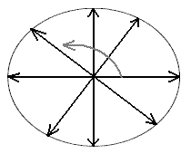
Figure 1. A rotating arrow of fixed length describing a circle.
Now suppose that when rotating this arrow we stretch and squeeze it in a variable manner and up to a maximum and minimum length. Instead of a circle the arrow now describes a two-dimensional ellipsoid.
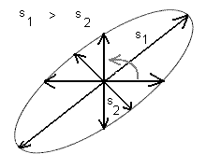
Figure 2. A rotating arrow of variable length describing an ellipsoid.
This is exactly what a matrix does to a vector.
When we multiply a vector X by a matrix A to create a new vector AX = Y, the matrix performs two operations on the vector: rotation (the vector changes coordinates) and scaling (the length of the vector changes). In terms of SVD, the maximum stretching and minimum squeezing is determined by the singular values of the matrix. These are values inherent, unique or "singular" to A that can be uncovered by the SVD algorithm.
Singular values describe the extent by which the matrix distorts the original vector and, thus, can be used to highlight which dimension(s) is/are affected the most by the matrix. Evidently, the largest singular value has the greatest influence on the overall dimensionality of the ellipsoid.
Now instead of a rotating vector depicts a set of m-dimensional vectors, all perpendiculars (orthogonal), with different lengths and defining a m-dimensional ellipsoid. The ellipsoid is embedded in an m-dimensional space, where m = k, with k being the number of nonzero singular values. If we eliminate dimensions by keeping the three largest singular values, a three-dimensional ellipsoid is obtained. Now suppose that compared with the two largest singular values the third one is small enough that we ignore it. This is equivalent to removing one dimension. Geometrically, the 3-dimensional ellipsoid collapses into a 2-dimensional ellipsoid.
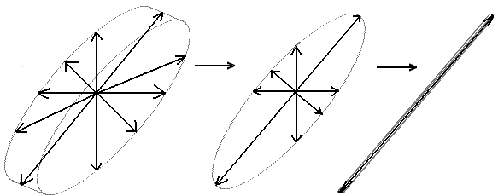
Figure 3. Dimensionality Reduction.
Singular values can be used to highlight which dimensions are affected the most when a vector is multiplied by a matrix. Thus, the decomposition allows us to determine which singular values can be retained.
This helps in reducing the dimensionality of the search space from all the words (dimensions) to the most influencing ones.
Computing matrices U, S and V^{T}
First matrices AA^{T} and A^{T}A are computed using matrix A. Then eigenvalues of AA^{T} or A^{T}A are computed. Both AA^{T} and A^{T}A give same characteristic equation and same eigenvalues.
Once eigenvalues from either the left or right matrix are obtained these are ordered in decreasing order (in the absolute sense) like this
| c₁ | > | c₂ | > | c₃ | ... > | c_{n} |
Then, taking their square roots yields
s₁ > s₂ > s₃ ... > s_{n}
which are the singular values of the original matrix. Matrix S is computed by placing values in descending order along its main diagonal.
Using the ordered eigenvalues[11], eigenvectors of A^{T}A are calculated and placed along the columns of matrix V. Then, transpose of matrix V i.e. V^{T} is calculated.
U matrix is computed using the equation U=AVS⁻¹.
U and V matrices obtained are orthogonal matrices.
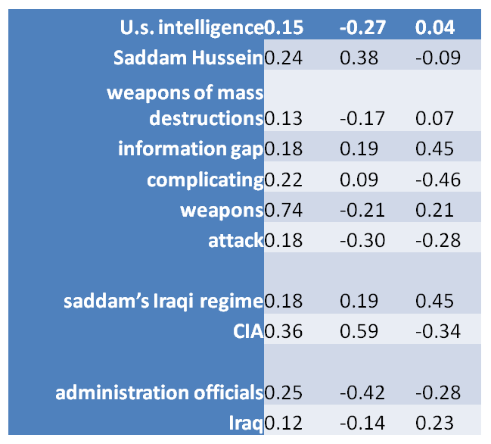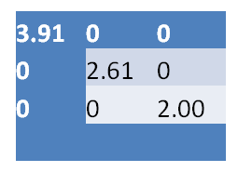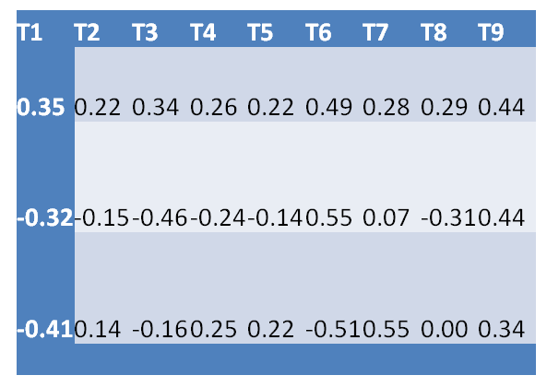

Mapping in Concept Space

The documents and words are mapped to the same concept space. In this space we can cluster documents, cluster words, and see how these clusters coincide so we can retrieve documents based on words. The concept space has vastly fewer dimensions compared to the original matrix. The dimensions are chosen specifically so that they contain the most information and least noise. This makes the new concept space ideal for running further algorithms such as ranking algorithms[12].
The U matrix gives us the coordinates of each word on our “concept” space, the V^{T} matrix gives us the coordinates of each document in our “concept” space, and the S matrix of singular values gives us a clue as to how many dimensions or “concepts” we need to include.
First dimension is not considered while plotting the points on the concept map. For documents, the first dimension correlates with the length of the document. For words, it correlates with the number of times that word has been used in all documents. If we had centered our matrix, by subtracting the average column value from each column, then we would use the first dimension.
Leaving out the first dimension, second and third dimensions are graphed using a XY graph. For words, second column of U matrix acts as X coordinate and third column acts as Y coordinate. For documents, second row of V^{T} matrix acts as X coordinate and third row acts as Y coordinate.

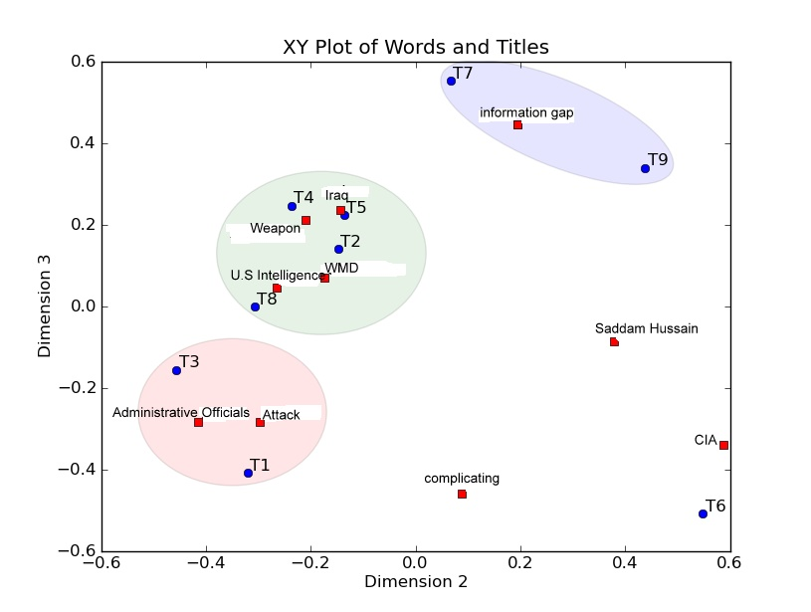

2.4 Ranking

Importance

Information Retrieval (IR) Systems are the predecessors of Web and search engines. These systems were designed to retrieve documents in curated digital collections such as library abstracts, corporate documents, news, etc. Traditionally, IR relevance ranking algorithms were designed to obtain high recall on medium-sized document collections using long detailed queries. Furthermore, textual documents in these collections had little or no structure or hyperlinks.

For most queries, there exist thousands of documents containing some or all of the terms in the query. A search engine needs to rank them in some appropriate way so that the first few results shown to the user will be the ones that are most pertinent to the user’s need.The interest of a document with respect to the user query is referred to as “document relevance.” This quantity is usually unknown and must be estimated from features of the document & the query.

SVD maps documents in k dimensional space in which conceptually related documents are clustered. In order to rank the top results, k-D tree is an efficient data structure available.

2.4.1 KD-Tree for Nearest Neighbor Search

A kd-tree (short for k-dimensional tree) is a space-partitioning data structure for organizing points in a k-dimensional space. kd-trees are a useful data structure for several applications, such as searches involving a multidimensional search key (e.g. range searches and nearest neighbour searches)[15]. kd-trees are a special case of BSP trees.
The kd-tree is a binary tree in which every node is a k-dimensional point. Every non-leaf node can be thought of as implicitly generating a splitting hyperplane that divides the space into two parts, known as subspaces. Points to the left of this hyperplane represent the left sub-tree of that node and points right of the hyperplane are represented by the right sub-tree. The hyperplane direction is chosen in the following way: every node in the tree is associated with one of the k-dimensions, with the hyperplane perpendicular to that dimension's axis[16]. So, for example, if for a particular split the "x" axis is chosen, all points in the subtree with a smaller "x" value than the node will appear in the left subtree and all points with larger "x" value will be in the right sub tree. In such a case, the hyperplane would be set by the x-value of the point, and its normal would be the unit x-axis.

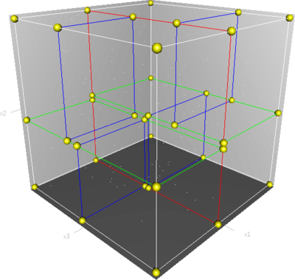
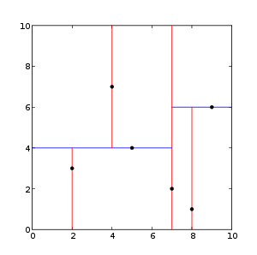

A 3-D Tree A 2-D Tree

The V matrix obtained from the SVD phase is used to construct the k-D tree where k is defined by the number of influential keywords (between 50-300) in the query. The U matrix (also obtained from SVD) serves as a list of points which are searched in the tree. Thus, a Nearest-Neighbor (NN) search is made for each and every word in U and documents returned from these searched are then collectively used to form the final ranked search result.

2.4.2 Nearest Neighbor Search (NN-Search)
Nearest neighbor search (NNS), also known as proximity search, is an optimization problem for finding closest points in metric spaces. The problem is: given a set S of points in a metric space M and a query point q ∈ M, find the closest point in S to q. In many cases, M is taken to be d-dimensional Euclidean space and distance is measured by Euclidean distance.

The NN Search works as a successive approximation. It first determines the immediate closest neighbor in the current hyper-space and then searched whether exists any other point in any other hyper-space which is closer than the currently chosen closest point.

CHAPTER 3
Concept Based Retrieval Implementation
The bottom-line of our project work lies in retrieving documents from a search browser which are more conceptually related to the fired query. We will now explain our project work with an example randomly picked from any journal.
Test Query for explanation:
“Microsoft Windows is a series of software and graphical user interfaces produced by Microsoft. Microsoft first introduced an operating environment named Windows on November 20, 1985 as an add-on to MS-DOS in response to the growing interest in graphical user interfaces (GUIs). Microsoft Windows came to dominate the world's personal computer market, overtaking Mac, which had been introduced in 1984. As of October 2009, Windows had approximately 91% of the market share for usage on the Internet. The most recent client version of Windows is Windows 7; the most recent server version is Windows Server 2008 R2.”

3.1 Part of Speech (POS) and Generalization Implementation
When the above stated is passed for POS tagging, each word is tagged with its respective part of speech and is indexed into an array of words. Hypernym Generalization Algorithm starts with a single word, finds a related word from the rest of the words .If they are closely related then a generalized meaning is taken out from this two words and added to the search space.
To speed up the algorithm, the results from tagger is used. Now, during generalization only the words from same part-of-speech is used to generalize. Lot of comparisons are saved because of this kind of generalization .Also if a word came with different context (both noun and verb) multiple times in query then it is generalized in those context separately.
Algorithm:

OriginalWordsList = [Words From current web page];
GeneralisedWordsList = [];
RelationshipMaxLength = 2;
WHILE (OriginalWordsList.Size > 2)
BestRelationShip = NULL;
CurrentWord = remove first word from OriginalWordsList
FOR (i = 0; i < OriginalWordsList.Size)
Get all relationships between all senses of CurrentWord
and all senses of OriginalWordsList element i, and
for each relationship compute the number of edges
in the WordNet taxonomy between CurrentWord and
OriginalWordsList element i
Get the relationship with the shortest number of edges,
out of all relationships identified in previous step

IF (number of edges in the shortest relationship !=
RelationshipMaxLength)
Save shortest relationship as BestRelationship:
BestParent = the parent (generalized) word
BestSecondWord = OriginalWordsList element i
END FOR
IF (BestRelationship != NULL)
Add BestParent to GeneralisedWordList
Remove BestSecondWord from the OriginalWordsList
ELSE
Add CurrentWord to GeneralisedWordsList
END WHILE
NewList=Union(OriginalList , GeneralisedWordList)
The results after POS tagging and Hypernym generalization are:
The nouns obtained after generalization are :
['computer_code', 'code', 'entity', 'relation', 'group', 'mental_condition', 'writing', 'environment', 'window', 'program', 'state_of_mind', 'stratum', 'usage', 'data_processor', 'world', 'month', 'condition', 'gui', 'server', 'abstract_entity', 'activity', 'cognitive_state', 'software_package', 'grouping', 'computing_machine', 'people', 'series', 'computer_program', 'electronic_computer', 'computer', 'measure', 'psychological_state', 'event', 'wonder', 'ms-dos', 'state', 'version', 'market', 'internet', 'instrumentality', 'period_of_time', 'operating', 'interface', 'november', 'socio-economic_class', 'computer_software', 'r2', 'information_processing_system', 'amount', 'act', 'programme', 'whole', 'software', 'artefact', 'coding_system', 'communication', 'human_action', 'period', 'psychological_condition', 'computer_programme', 'involvement', 'unit', 'human_activity', 'response', 'interest', 'percentage', 'fundamental_quantity', 'possession', 'calendar_month', 'artifact', 'part', 'october', 'software_program', 'package', 'attribute', 'software_system', 'share', 'written_communication', 'deed', 'instrumentation', '%', 'black_and_white', 'computing_device', 'machine', 'psychological_feature', 'status', 'abstraction', 'object', 'physical_object', 'mac', 'user', 'curiosity', 'device', 'time_period', 'class', 'Gregorian_calendar_month', 'physical_entity', 'user_interface', 'assets', 'fundamental_measure', 'mental_state', 'portion', 'client', 'written_language', 'social_class', 'microsoft', 'came', 'quantity']

The Verbs are:
[' 'represent', 'named', 'intercommunicate', 'is', 'move', 'rest', 'produced', 'typify', 'cost', 'exist', 'convey', 'follow', 'cultivate', 'use', 'develop', 'raise', 'make_up', 'interact', 'give', 'had', 'been', 'occupy', 'live', 'take', 'impart', 'embody', 'dominate', 'tell', 'use_up', 'be', 'intend', 'get', 'farm', 'acquire', 'communicate', 'stay', 'symbolise', 'stand_for', 'produce', 'grow', 'change', 'constitute', 'expend', 'symbolize', 'windows', 'equal', 'leave', 'inform', 'remain', 'pass_on', 'personify', 'act', 'growing', 'introduced', 'overtaking', 'comprise', 'mean']

From the above list of words the words like:
[‘Software_package’,’software_system’,coding_system’,’computer_software’] are all second level generalizations of the words Windows and MS-DOS in our query .The first level generalization of the words Windows and MSDOS is the word Operating system. Thus we observe that due to generalization we obtain the essence of the document in the form of these words.

3.2 LSI Implementation
Principle:
LSI is based on the concept that words that are used in the same context, tend to have same meaning.

Mathematics of LSI
LSI uses common linear algebra techniques[13][14] to learn the conceptual correlations in a collection of text. In general, the process involves constructing a weighted term-document matrix, performing a Singular Value Decomposition on the matrix, and using the matrix to identify the concepts contained in the text.
LSI begins by constructing a term-document matrix, A, to identify the occurrences of the m unique terms within a collection of n documents. In a term-document matrix, each term is represented by a row, and each document is represented by a column, with each matrix cell, aij, initially representing the number of times the associated term appears in the indicated document, tfij. This matrix is usually very large and very sparse. Once a term-document matrix is constructed, weighting functions TF-IDF is applied to it to condition the data. The weighting functions transform each cell, aij of A, to be the product of a local term weight, lij, which describes the relative frequency of a term in a document, and a global weight, gi, which describes the relative frequency of the term within the entire collection of documents.
This weight is a statisticak measure used to evaluate how iportance a word is to a documet in a collecion or corpus. The importance icreases proportionally to the number of times a word appears in the document but is offset by the frequency of the word in the corpus[14].

TFIDFi,j = ( Ni,j / N*,j ) * log( D / Di )
Ni,j = the number of times word i appears in document j (the original cell count).
N*,j = the number of total words in document j (just add the counts in column j).
D = the number of documents (the number of columns).
Di = the number of documents in which word i appears (the number of non-zero columns in row i).

Ni,j / N*,j : This term is simply the number of times a given term appears in that document. This count is usually normalized to prevent a bias towards longer documents (which may have a higher term count regardless of the actual importance of that term in the document) to give a measure of the importance of the term i within the particular document j.

log( D / Di ) : The inverse document frequency is a measure of the general importance of the term.

A high weight in tf–idf is reached by a high term frequency (in the given document) and a low document frequency of the term in the whole collection of documents; the weights hence tend to filter out common terms. The tf-idf value for a term will be greater than zero if and only if the ratio inside the idf's log function is greater than 1. Depending on whether a 1 is added to the denominator, a term in all documents will have either a zero or negative idf, and if the 1 is added to the denominator a term that occurs in all but one document will have an idf equal to zero.

3.3 SVD Matrix Simulation

After performing LSI on the given set of words, We performed SVD simulation on the matrix obtained after LSI implementation. Due to the huge size of these matrices they are not included here.

3.4 Nearest Neighbour Search Implementation.

Algorithm --

The nearest neighbour (NN) algorithm aims to find the point in the tree which is nearest to a given input point. This search can be done efficiently by using the tree properties to quickly eliminate large portions of the search space. Searching for a nearest neighbour in a kd-tree proceeds as follows:
Starting with the root node, the algorithm moves down the tree recursively, in the same way that it would if the search point were being inserted (i.e. it goes left or right depending on whether the point is less than or greater than the current node in the split dimension).
Once the algorithm reaches a leaf node, it saves that node point as the "current best"
The algorithm unwinds the recursion of the tree, performing the following steps at each node:
If the current node is closer than the current best, then it becomes the current best.
The algorithm checks whether there could be any points on the other side of the splitting plane that are closer to the search point than the current best. In concept, this is done by intersecting the splitting hyperplane with a hypersphere around the search point that has a radius equal to the current nearest distance. Since the hyperplanes are all axis-aligned this is implemented as a simple comparison to see whether the difference between the splitting coordinate of the search point and current node is less than the distance (overall coordinates) from the search point to the current best.
If the hypersphere crosses the plane, there could be nearer points on the other side of the plane, so the algorithm must move down the other branch of the tree from the current node looking for closer points, following the same recursive process as the entire search.
If the hypersphere doesn't intersect the splitting plane, then the algorithm continues walking up the tree, and the entire branch on the other side of that node is eliminated.
When the algorithm finishes this process for the root node, then the search is complete.

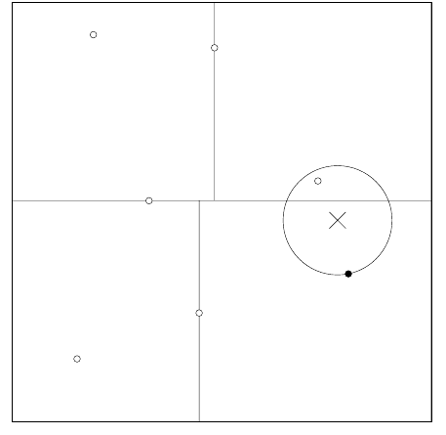

For example, in the above k-D tree if the NN search is launched for a keyword(cross) it firstly finds the nearest point in the current hyper-space(dark dot) as represented in the above figure. It then recursively searches its parents for any point which may be closer than the current point. Hence the second step can be represented as follows :-
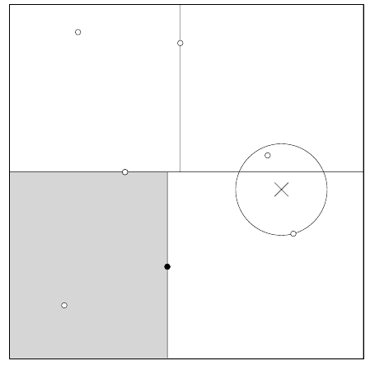

Finally it finds the nearest neighbor (the point inside the circle in the above figure).

The result of NN search is then searched for occurrences of documents and a documents are given proper weights depending on its ranking. This is done for each keyword present in the query, A sum of weights is calculated for all the documents and the documents arranged in a decreasing order of weight sum gives the final ranked result of the search mechanism.

3.5 Results

Finally, on applying the NN search we obtain the results as follows:

g_operating system_9.txt
g_operating system_2.txt
g_operating system_1.txt
g_operating system_3.txt
g_operating system_4.txt

CHAPTER 4
Experimental Set Up
The project is implemented in the Python programming language, which is scripting language with extensive libraries’ support. We chose this language due to its reduced syntactic complexity. The Natural Language Toolkit was readily and freely available for various requirements of the project.
As an IDE we used the Netbeans [16] and Eric [17]. Google Code & Mercurial was used for hosting and coordination. The inbuilt PoS tagger of the NLTK was used for tagging and tokenization. The Inflect library[18] was used for converting plural forms of words to singular.
Initially the database of documents is scanned for building a hash table which is then dumped on the stable storage using the Pickle Library(c Pickle - C implementation of the Pickle library). If any document is to be added later on we prepare an incremental dump.
The hash table is imported in appropriate data structures when the system is booted. The binary dumps made lead to fast booting. This hash table is then used as a data set for the search mechanism. The front end dialogue box is designed and implemented using the WxGlade[19] GUI design tool.

CHAPTER 5
Conclusion and Future Prospects
Conclusion
On analysis of these documents we observed that the document ranked 1 had very less word count and thus the term frequency for this document was high. Thus in essence it had much more relevance to the searched query and the content was concentrated around the searched query. As we move further down the results we observed that the documents size increased as well as relevance decreased. The third and fourth results had approximately the same number of words but the content of the third result had many more words in our generalized wordlist set thus the term frequency was slightly higher.
The comparison with Google’s result revealed the following observations :

1. This algorithm focuses on the size of the document .Generally the user interest dwindles as the page is read. Thus a document with lesser words, still focussed on the topic is much more appreciated.

2. Our results are ranked based on the concept of the document rather than the Page Rank weights.

3. This approach is immune to attacks based on link farms.

At the same time, to influence the results, the document can be added with random words which may be part of a more general generalized wordlist, thus tilting the result in favour of the document. The search mechanism cannot properly handle single keyword/short queries as the mapping takes place on very few dimensions which lead to large information loss. The current mechanism is proposed for text based documents only; multimedia content cannot be handled.

5.1 Future Prospects:

1. This algorithm can be used to query documents based on concepts.

2. It can be applied to information retrieval systems in order to fetch documents related to a certain central theme formed as a query.
3. The generalized wordlist obtained from this algorithm can be used to suggest better search keywords for search engines optimization.
4. We can implement the mechanism on Wikipedia as a dataset which will lead to a better user experience.

REFERENCES

[1]. Best Practices Commentary on the Use of Search and Information Retrieval Methods in E-Discovery, the Sedona Conference, 2007, pp. 189–223.
[2]. DeRose, Steven J. 1988. "Grammatical category disambiguation by statistical optimization."
[3]. The Penn Tree Bank project < http://www.cis.upenn.edu/~treebank/ >
[4]. Charniak, Eugene. 1997. "Statistical Techniques for Natural Language Parsing". AI Magazine 18(4):33–44
[5] . Bates, M. (1995). Models of natural language understanding. Proceedings of the National Academy of Sciences of the United States of America, Vol. 92, No. 22 (Oct. 24, 1995), pp. 9977–9982.
[6] Gong, Y., and Liu, X., Creating Generic Text Summaries, Proceedings, Sixth International Conference on Document Analysis and Recognition, 2001, pp. 903–907.
[7]. Zukas, Anthony, Price, Robert J., Document Categorization Using Latent Semantic Indexing, White Paper, Content Analyst Company, LLC
[8]. Richard Timian. “LSI- Leadership and Organizational Behavior,Friday”, September 14, 2007.
[9]. Dumais, S., Latent Semantic Analysis, ARIST Review of Information Science and Technology, vol. 38, 2004, Chapter 4.
[10]. Wall, Michael E., Andreas Rechtsteiner, Luis M. Rocha (2003). "Singular value decomposition and principal component analysis".
[11]. Hansen, P. C. (1987). "The truncated SVD as a method for regularization". BIT 27: 534–553.
[12]. Samet, H. (2006). Foundations of Multidimensional and Metric Data Structures. Morgan Kaufmann.
[13]. Landauer, Thomas K., and Dumais, Susan T., Latent Semantic Analysis, Scholarpedia, 3(11):4356, 2008.
[14]. Jolliffe, L. T., Principal Component Analysis, Springer-Verlag, New York, (1986).
[15] Variable KD-Tree Algorithms for Spatial Pattern Search and Discovery by Jeremy Kubica, Joseph Masiero, Andrew Moore, Robert Jedicke, and Andrew Connolly. to appear in Advances in Neural Information Processing Systems, 2005.
[16] The Netbeans IDE <www.netbeans.org>
[17] Eric IDE < www.eric-ide.python-projects.org>
[18] The Inflect Library <http://www.pypi.python.org/pypi/inflect>
[19] Vromans, Johan (2005-10-24). "GUI development with wxGlade". Squirrel Consultancy. Retrieved 2011-04-16.

